MAHARASHTRA STATE BOARD OF TECHNICAL EDUCATION (MSBTE) MUMBAI

**INSTITUTE OF ENGINEERING & TECHNOLOGY,**

**KANNAD DIST.AURANGABAD.**



**PROJECT REPORT ON**

**“SMART IRRIGATION SYSTEM USING IOT”**

**UNDER THE GUIDANCE OF**

**Prof.V.T.Rathod**

**SUBMITTED BY:**

**Archana Shivnath Pande**

**Komal Kadunath Sawai**

**Mayuri Bapurao Janjal**

**Priyanka Balu Rahane**

**DEPARTMENT OF COMPUTER ENGINEERING**

**YEAR 2019-20**

MAHARASHTRA STATE BOARD OF TECHNICAL EDUCATION (MSBTE) MUMBAI

**INSTITUTE OF ENGINEERING & TECHNOLOGY,**

**KANNAD DIST.AURANGABAD.**



PROJECT REPORT ON

“SMART IRRIGATION SYSTEM USING IOT”

UNDER THE GUIDANCE OF

**Prof.V.T.Rathod**

**SUBMITTED BY:**

**Archana Shivnath Pande**

**Komal Kadunath Sawai**

**Mayuri Bapurao Janjal**

**Priyanka Balu Rahane**

**DEPARTMENT OF COMPUTER ENGINEERING**

**YEAR 2019-20**

V.P.S.P.M’S

**INSTITUTE OF ENGINEERING & TECHNOLOGY, KANNAD**

Department of Computer Engineering



**CERTIFICATE**

This is to certify that the seminar report entitled **“Smart Irrigation System using IoT”**, which is being to submit here with for the award of the diploma in “**Computer Engineering**” of Maharashtra State Board of Technical Education Mumbai. This is contribution by **Archana S. Pande, Komal K. Sawai, Mayuri B. Janjal,** and **Priyanka B. Rahane** under supervision and guidance of **Prof.V.T.Rathod.**

**Project Guide HOD Principal**

**Prof. V.T.Rathod Prof .N.S.Magar Prof.A.V.Wavre**

**External Examiner**

**ACKNOWLEDGEMENT**

I would like to take this opportunity to express my profound gratitude and deep regard to my (**Prof. V.T.Rathod**), for his exemplary guidance, valuable feedback and constant encouragement throughout the duration of the project. His valuable suggestions were of immense help throughout my project work. His perceptive criticism kept me working to make this project in a much better way. Working under him was an extremely knowledgeable experience for me

**ABSTRACT**

India is mainly an agricultural country. Agriculture is the most important occupation for the most of the Indian families. It plays vital role in the development of agricultural country. In India, agriculture contributes about 16% of total GDP and 10% of total exports. Water is main resource for Agriculture. Irrigation is one method to supply water but in some cases there will be lot of water wastage. So, in this regard to save water and time we have proposed project titled smart irrigation system using IoT. In this proposed system we are using various sensors like temperature, humidity, soil moisture sensors which senses the various parameters of the soil and based on soil moisture value land gets automatically irrigated by ON/OFF of the motor. These sensed parameters and motor status will be displayed on user blynk application.

**LIST OF FIGURE**

|  |  |  |
| --- | --- | --- |
| **Figure** | **Description** | **Page** |
| 1.2.1 | Surface Irrigation | 2 |
| 1.2.2 | Drip Irrigation | 2 |
| 1.2.3 | Sprinkler Irrigation | 3 |
| 3.2.1 | Node MCU | 8 |
| 3.2.2 | Soil Moisture Sensor | 9 |
| 3.2.3 | DHT11 Sensor | 10 |
| 3.2.4 | Relay | 11 |
| 3.2.5 | Mini Water Pump | 12 |
| 3.2.6 | Arduino IDE | 13 |
| 3.2.7 | Blynk | 14 |
| 3.3.1 | Create New Account | 15 |
| 3.3.2 | Blynk | 16 |
| 3.3.3 | New Project | 17 |
| 3.3.4 | Widget Box | 18 |
| 3.3.5 | IoT Irrigation | 19 |
| 3.5.1 | Circuit Diagram | 21 |
| 3.6.1 | Actual Connection | 22 |
| 3.7.1 | Flow Diagram | 23 |
| 4.1.1 | IoT Irrigation Result 1 | 25 |
| 4.1.2 | IoT Irrigation Result 2 | 26 |

**LIST OF TABLE**

**Table Description Page**

3.4.1 Circuit Connection 20

**CONTENTS**

|  |  |  |
| --- | --- | --- |
| **Chapter 1:** | **Introduction** |  |
| 1.1 | Introduction | 1 |
| 1.2 | What is Irrigation? | 2 |
| 1.3 | Problem Statement | 4 |
| 1.4 | Objective | 5 |
| **Chapter 2:** | **Literature Survey** |  |
| 2.1 | Literature Survey | 6 |
| **Chapter 3:** | **System Development** |  |
| 3.1 | Components Required | 7 |
| 3.2 | Components Description | 8 |
|  | 1 Node MCU | 8 |
|  | 2 Soil Moisture Sensor | 9 |
|  | 3 DHT11 Sensor | 10 |
|  | 4 Relay | 11 |
|  | 5 Mini Water Pump | 12 |
|  | 6 Arduino IDE | 13 |
|  | 7 Blynk | 14 |
| 3.3 | Step to create blynk application | 15 |
| 3.4 | Circuit Connection | 20 |
| 3.5 | Circuit Diagram | 21 |
| 3.6 | Actual Circuit Connection | 22 |
| 3.7 | Flow Diagram | 23 |
| 3.8 | Working of System | 24 |
| **Chapter 4:** | **Experimental Result** |  |
| 4.1 | Experimental Result | 25 |
| 4.2 | Advantages | 27 |
| **Chapter 5:** | **Conclusion & Scope of project** |  |
| 5.1 | Scope of project | 28 |
| 5.2 | Conclusion | 29 |
| **References** |  | 30 |

**Chapter 1: INTRODUCTION**

**1.1 Introduction**

Agriculture is the backbone of Indian Economy. In today’s world, as we see rapid growth in global population, agriculture becomes more important to meet the needs of the human race. However, agriculture requires irrigation and with every year we have more water consumption than rainfall, it becomes critical for growers to find ways to conserve water while still achieving the highest yield. But in the present era, the farmers have been using irrigation technique through the manual control in which they irrigate the land at the regular interval.

In the current phase, one of the world's major problems is lack of water and water is consumed abundantly in agriculture. Therefore an appropriate water consumption system is required. Currently, almost all irrigation systems are physically regulated.

IoT is changing the agriculture domain and empowering farmers to fight with the huge difficulties they face. The Internet of Things (IoT) is a technology where in a mobile device can be used to monitor the function of a device. The Internet of Things (IoT) is concerned with interconnecting communicating objects that are installed at different locations that are possibly distant from each other. Internet of Things (IoT) is a type of network technology, which senses the information from different sensors and makes anything to join the Internet to exchange information.

The proposed smart irrigation system has been designed to overcome the unnecessary water flow into the agricultural lands. Temperature, moisture and humidity readings are continuously monitored by using temperature, moisture and humidity sensor and send these values to the blynk app. then as per need of water to crop user can ON/OFF motor from blynk app installed in mobile. The application is a simple menu driven application, with 4 options. This includes motor status, moisture, temperature and humidity values. The motor status indicates the current status of the pump.

**1.2 What is Irrigation?**

Irrigation is the artificial application of water to the land or soil. It is used to assist in the growing of agricultural crops, maintenance of landscapes, and revegetation of disturbed soils in dry areas and during periods of inadequate rainfall. Irrigation also had few other uses in crop production, which include protecting plants against frost.

**There are three type of irrigation :-**

1. Surface Irrigation

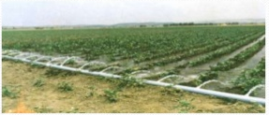

Fig 1.2.1 Surface Irrigation

1. 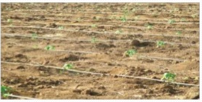 Drip Irrigation

Fig 1.2.2 Drip Irrigation

1. Sprinkler Irrigation

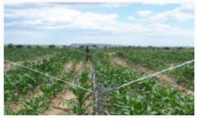

Fig 1.2.3 Sprinkler Irrigation

* 1. **Problem Statement**

In the case of traditional irrigation system irrigation is done manually by farmers. Since the water is irrigated directly in the land, plants under go high stress from variation in soil moisture, therefore plants appearance is reduced. The absence of automatic controlling of the system result in improper water control system the major reason for these limitations rate.

At present there is emerging global water crisis where managing scarcity of water has become a serious job. This growth can be seen in countries which have shortage of water resources and are economically poor.so this is the serious problem in traditional irrigation system.

Over irrigation because of poor distribution uniformity or management wastes water, chemicals, and may lead to water pollution.

Under irrigation leads to increased soil salinity with consequent buildup of toxic salts on soil surface in areas with high evaporation.

Farm lands and field situated miles away from your home. Extensive travel required, sometimes several times in a day to start and stop the irrigation water pumps.

* 1. **Objective**
* To save water and reduce human intervention in the agriculture field.
* In today’s world due to irrigation there might be some possible wastages. It may be water wastages, wastages of crop and so on.
* By using this system it will possibly reduce such wastages.
* Continuously monitoring the status of sensors and provide signal for taking necessary action.
* To get the output of soil moisture sensor and provide water to crop.
* It shows basic switching mechanism of motor using sensors by sensing moisture present in the soil.

**Chapter 2: LITERATURE SURVEY**

* 1. **Literature Survey**

Primary investigation is carried out under the following stages, such as Understanding the existing approaches, Understanding the requirements, developing an abstract for the system.

In this paper, soil moisture sensor, temperature and humidity sensors placed near plant and transmit data to blynk application. Threshold value of soil moisture sensor that was programmed into a microcontroller to control water quantity. Temperature, humidity and soil moisture values are displayed on the blynk application.

"Automatic Irrigation System on Sensing Soil Moisture Content" is intended to create an automated irrigation mechanism which turns the pumping motor ON and OFF on detecting the dampness content of the earth. In this paper only soil moisture value is considered but proposed project provided extension to this existed project by adding temperature and humidity values.

“Automatic irrigation system” in this irrigation is carried out using soil moisture values but extend to this proposed system displays temperature and humidity values.

“Automatic gardening system” in this motor ON/OFF automatically as per soil moisture values but extend to this proposed system user can ON/Off motor from remote location.

By referring all above system it is found that no such systems are existed with all integrated features but proposed system includes these all features such as displaying temperature, humidity and soil moisture values and also automatic switching on and off of motor by considering soil moisture values.

**Chapter 3: SYSTEM DEVELOPMENT**

**3.1Components Required**

**Hardware**

1. NodeMCU
2. Soil moisture Sensor
3. DHT11 Sensor
4. Relay (2 Channel)
5. Mini Water pump
6. 9v Battery

**Software**

1. Arduino IDE (1.8.9)
2. Blynk

**3.2 Components Description**

**1. Node MCU**

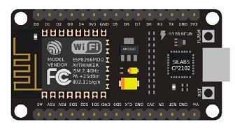

Fig 3.2.1 .Node MCU

NodeMCU is used as controller unit. It is used to control the system. NodeMCU is a low-cost, Wi-Fi module chip that can be configured to connect to the internet.

NodeMCU is having 4MBytes of ROM. it is an open source IoT platform. It includes firmware which runs on the ESP8266 Wi-Fi Soc from Espressif System.

General-purpose input/output (GPIO) is a pin on an IC (Integrated Circuit). It can be either input pin or output pin, whose behavior can be controlled at the run time.

NodeMCU Development kit provides access to these GPIOs of ESP8266. The only thing to take care is that NodeMCU Dev kit pins are numbered differently than internal GPIO notations of ESP8266.

**2. Soil Moisture Sensor**

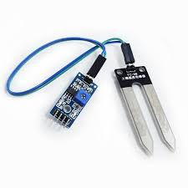

Fig 3.2.2 Soil Moisture Sensor

The Moisture sensor is used to measure the water content (moisture) of soil. When soil having water shortage, the module output is at high level, else the output is at low level. This sensor reminds the user to water their plants and also monitors the moisture content of soil.

Copper electrodes are used to sense the moisture content of soil. In this sensor we are using two probes to be dipped into soil as per moisture we will get analog signal.

1. **DHT11 Sensor**

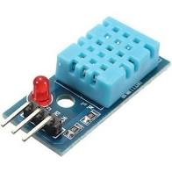

Fig 3.2.3 DHT11 Sensor

The DHT11 is a basic, ultra low-cost digital temperature and humidity sensor. It uses a capacitive humidity sensor and a thermistor to measure the surrounding air and spits out a digital signal on the data pin. It’s fairly simple.

The humidity sensing components of the DHT11 is a moisture holding substrate with the electrodes applied to surface. The DHT11 converts the resistance measurement to relative humidity on a chip mounted to back of the unit and transmits the humidity and temperature readings to the NodeMCU.

1. 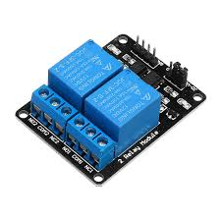**Relay**

Fig 3.2.4 Relay

A relay is an electromagnetic switch that is used to turn on and turn off a circuit by a low power signal, or where several circuits must be controlled by one signal.

The main operation of a relay comes in places where only a low-power signal can be used to control a circuit. It is also used in places where only one signal can be used to control a lot of circuits. The application of relays started during the invention of telephones. They played an important role in switching calls in telephone exchanges. They were also used in long distance telegraphy. They were used to switch the signal coming from one source to another destination. After the invention of computers they were also used to perform Boolean and other logical operations. The high end applications of relays require high power to be driven by electric motors and so on. Such relays are called contactors

**5. Mini Water Pump**

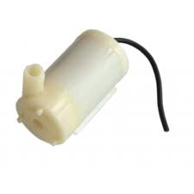

Fig 3.2.5 Mini Water Pump

This water pump used to supply water to the plant as per input given by microcontroller.

This is a low cost mini submersible type water pump that works on 3-6V DC. It is extremely simple and easy to use. Just immerse the pump in water, connect a suitable pipe to the outlet and power the motor with 3-6V to start pumping water.

This motor is small, compact and light. It can be controlled from a micro controller/Arduino using our DC Motor Drivers or one of our Relay Boards.

1. **Arduino IDE**

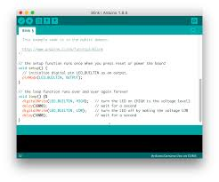

Fig 3.2.6 Arduino IDE

The Arduino Integrated Development Environment (IDE) is a cross-platform application (for windows, macOS, Linux) that is written in functions from c and c++.

The Arduino IDE supplies a software library from the wiring project, which provides many common input and output procedures.

* Use: Check Condition
* Writing Sketches: Program written using Arduino software are called sketches
* Upload: Compiles your code and uploads it to the configured board
* New: Creates a new sketch
* Save: Saves your sketch
* Serial Monitor: File,Edit,sketch,Tools,Help

**7. Blynk**

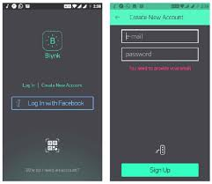

Fig 3.2.7 Blynk

Blynk is a Platform with IOS and Android apps to control Arduino, Raspberry Pi, NodeMCU and the likes over the internet. It’s a digital dashboard where you can build a graphic interface for your project by simply dragging and dropping widgets.

After downloading the Blynk app, you can create a project dashboard and arrange buttons, sliders, graphs, and other widgets onto the screen.

**3.3 Step to create blynk application**

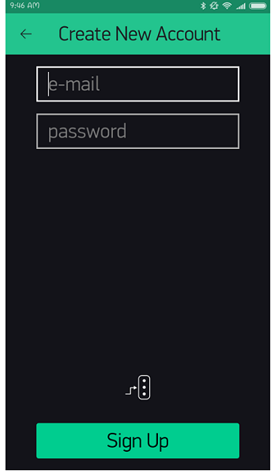

Fig 3.3.1 Create New Account

Create your email account to sign up.

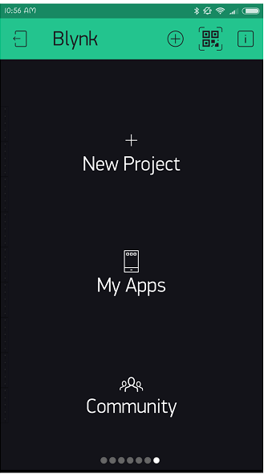

Fig 3.3.2 Blynk

Select New Project.

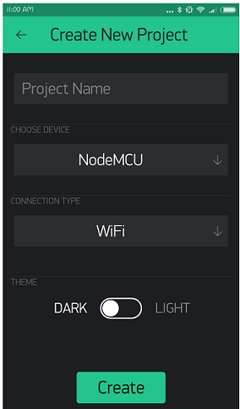  
 Fig 3.3.3 New Project

Create New Project.

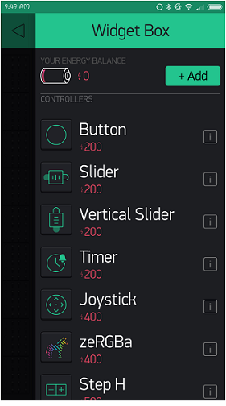

Fig 3.3.4 Widget Box

Select Different Widget from Widget Box.

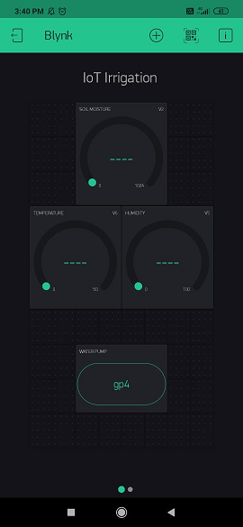

Fig 3.3.5 IoT Irrigation

**3.4 Circuit Connection**

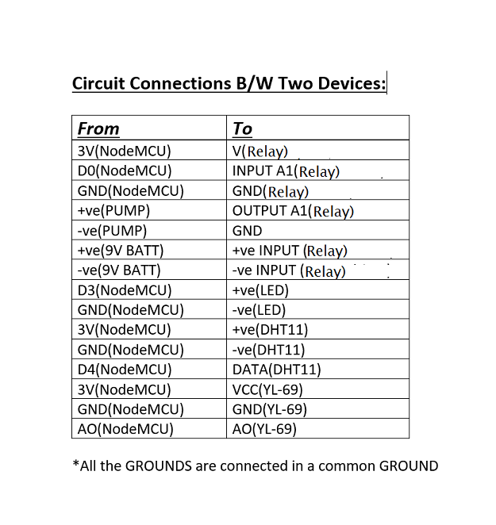

Table 3.4.1 Circuit Connection

**3.5 Circuit Diagram**

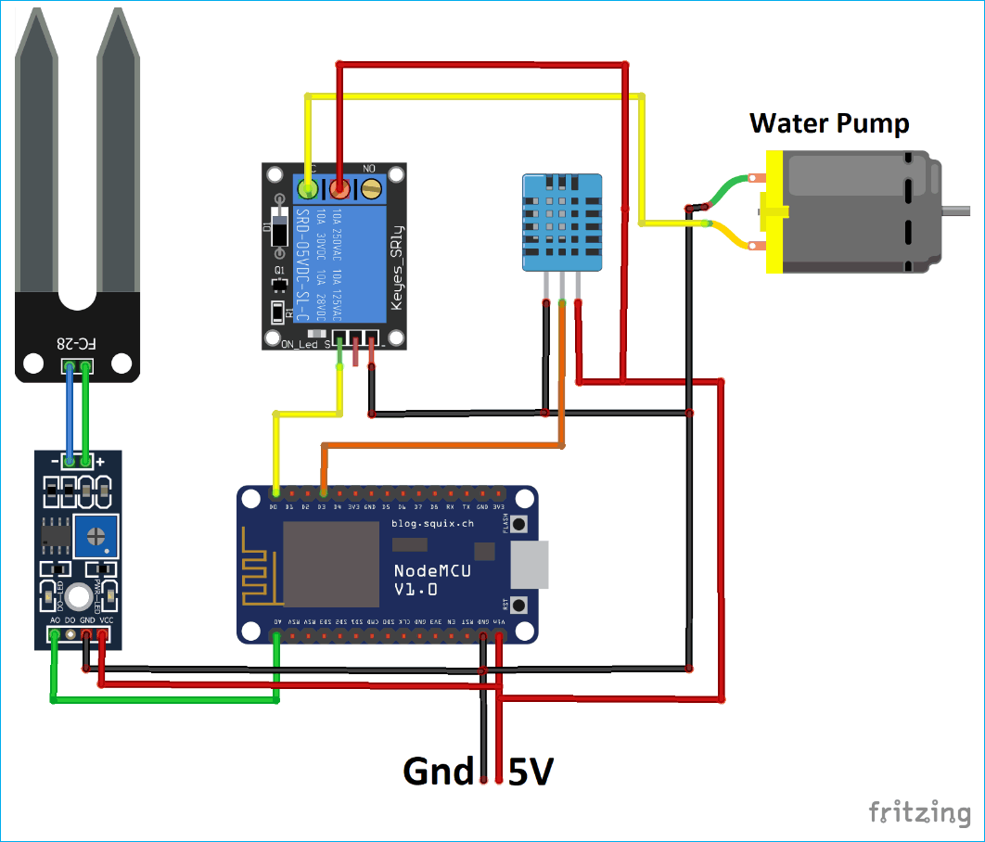

Fig 3.5.1 Circuit Diagram

**3.6 Actual Circuit Connection**

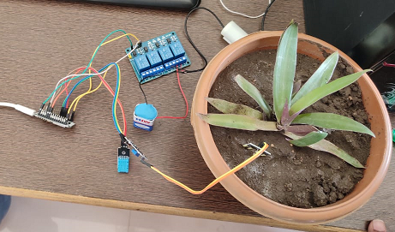

Fig 3.6.1 Actual Connection

**3.7 Flow Diagram**

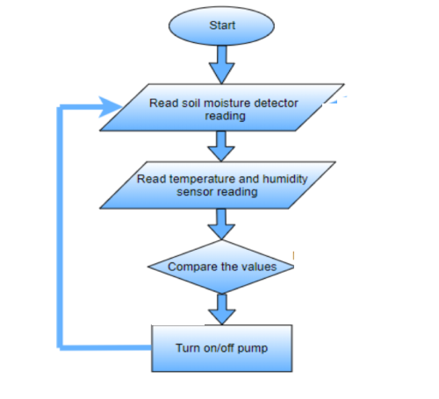

Fig 3.7.1 Flow Diagram

**3.8 Working of System**

In agriculture field sensors are used like soil moisture sensor, temperature sensor, humidity sensor. The information received from the sensors is sent to the blynk application.in the control section, the system is activated using blynk application in which ON/OFF button used.

The application has feature like taking water to the plants in agriculture field when the user start the water pump from remote location.in this system there is a switch used to turn ON/OFF water supply to the plants from remote location.

When we give the power supply to NodeMCU then it start the reading the values of soil moisture, Temperature, Humidity around crops.

It continuously give the moisture, Temperature and humidity values to user on his blynk app.When if crop required water then we start the water pump by clicking ON/OFF button in the blynk app.When we ON water pump then water supply start to the crop.

**Chapter 4: EXPERIMENTAL RESULT**

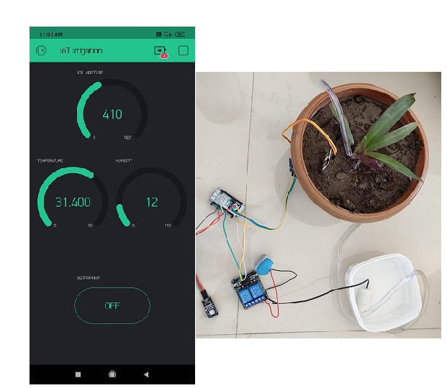**4.1 Experimental Result**

Fig 4.1.1 IoT Irrigation Result 1

Firstly check all connection are proper or not. Start the blynk application in the mobile and ON the mobile data. Then system start working in following ways:

* Soil moisture read the values of moisture contents in soil.
* Temperature sensor read the values of temperature around.
* Humidity sensor read the values of humidity.
* In the blynk application it shows values as

1. Soil moisture=410
2. Temperature=31.400
3. Humidity=12

* Yet we not start the water pump.

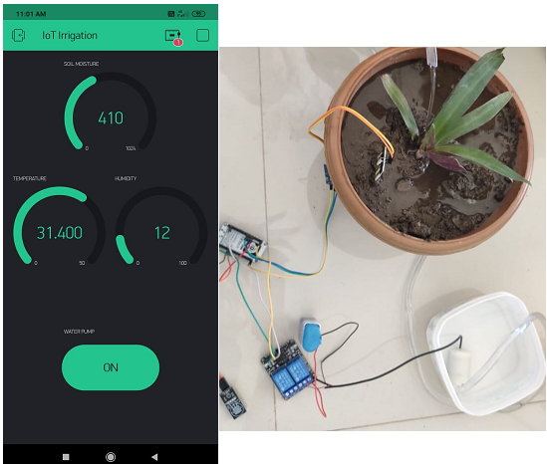

Fig 4.1.2 IoT Irrigation Result 2

As per soil moisture contents shows in blynk application start the water pump by clicking water pump button ON and start the water to the plants.

When water give to the plants in blynk application shows changes the value of soil moisture contents in soil.

As per given experimental result “Smart Irrigation System” work in proper ways. When we click on button of water pump in blynk application from anywhere then start water pump.

**4.2 Advantages**

* **Water Conservation:**

Soil moisture sensors allow for water use only when needed.

* **Real-Time Data give:**

Farmers can visualize soil moisture, temperature, humidity in real time and remotely.

* **Efficient and Saves Time:**

The machine-to-machine interaction provides better efficiency, hence accurate results can be obtained fast.

This results in saving valuable time.

* **Increase in productivity.**
* **Reduce soil erosion.**
* **Reduced water consumption**
* **No manpower required**

**Chapter 5: CONCLUSION & SCOPE OF PROJECT**

**5.1 Scope of Project**

We display the current status of the soil moisture contents levels, temperature values, humidity values, percentage of water utilized to water plants duration of time for which the water pump is ON.

To improve the efficiency and effectiveness of the system, the farmer should stop the system remote location.

System can be used:

* Irrigation in Fields.
* Irrigation in garden parks.
* Very efficient for paddy fields.
* Pisciculture.

**5.2 Conclusion**

The farmers working in the farm lands are solely dependent on the rains and bore wells for irrigation of land. We conclude that the system reduces water consumption and hence minimizes the wastage of water. In this system as we provide controlled supply of water and it improves the productivity.

Also due to an automated system the manpower is reduced.by implementing such a system using NodeMCU and sensors we increase agricultural yield.

A system to moisture levels in the soil was designed and the project provided an opportunity to study the existing systems, along with their features and drawbacks. The proposed system can be used to switch ON/OFF the water according to soil moisture levels there by automating the process of irrigation which is one of the most time consuming activities in farming.

The system uses information from soil moisture sensor to irrigate soil which is helps to prevent over irrigation and under irrigation of soil there by avoiding the crop damage.

**References**

* IoT based Smart Irrigation System using soil moisture sensor and ESP8266.
* IoT based Smart Irrigation System using NodeMCU ESP8266 and Adafruit IO.
* IoT based agriculture System using NodeMCU IRJET.
* Circuit Diagram for IoT based System.
* Smart Irrigation System based on soil moisture using iot-irjet.
* How to make automatic irrigation system using NodeMCU.
* IoT based irrigation, monitoring and controlling system.
* <https://www.viralsciencecreativity.com>.
* NodeMCU ESP8266 soil moisture/ water plants notification/ blynk